Appendix 5: Children’s Social Care Implementation Strategy

20 February 2023

Briefing for children’s social care placements working group

- This document outlines the key recommendations within the Children’s Social Care Implementation Strategy that specifically relate to the provision of placements.

Commitment | LGA View
The strategy states that “A family-based home is best for most children to live in. Children should receive local healthcare and whatever additional support they need, close to the family home that they are living in. Where children need specialist residential or therapeutic care, this should be provided as close to where they come from as possible.” | We are concerned that residential care for children appears to be given a far lower priority in this strategy than foster care. While family settings will be the best option for many children, our members have repeatedly highlighted that for some children in their care, residential children’s homes are the best choice, for example for some older children who express that they do not want to live in another family environment to the one they have grown up in. Research for the LGA highlighted that one of the barriers to developing new children’s homes is their perceived role as an “option of last resort”. If we are to ensure that we have the right homes for all children who need to come into care, we must ensure that a range of options is available and not introduce additional barriers as an unintended consequence of policy.
Investing £3 million in an initial fostering recruitment and retention programme in the North East Regional Improvement and Innovation Alliance. This will introduce a regional support hub to support individuals interested in applying to foster, facilitate targeted communications and improve retention with the evidence-based model Mockingbird. This will create end-to-end improvements in fostering recruitment and retention and allow us to gather insights ahead of further programmes. | It is positive the Mockingbird model is being rolled out in the North East however given that significant money has already been spent evaluating the model and finding it to be positive, it would have been helpful to support all councils to implement this or similar models rather than spending time gathering further insights.
We will expand our recruitment and retention programme from 2023 by investing over £24 million. In the development of fostering recruitment, we will work to recruit and retain more foster carers where there are particular shortages. Depending on local need, this may include sibling groups, teenagers, UASC, other children who have suffered complex trauma or parent and child foster homes. This will boost fostering capacity and build an evidence base on how to effectively recruit and retain foster carers | The LGA has long called for national support around the recruitment of foster carers, so investment in this is very welcome. We have also called for a focus on increasing foster care capacity for UASC as part of the DfE’s commitment to focussed work on fostering, so it is positive to see this recognised. There is already evidence around the recruitment and retention of foster carers available, so it will be important to build on this and to share evidence swiftly to build capacity quickly.
In recognition of the increasing costs of living, we are also raising the National Minimum Allowance (NMA). Foster carers will benefit from a 12.43% increase to the NMA. | Finances should not be a barrier to providing children in care with loving homes and an increase to the National Minimum Allowance will support foster carers to look after children. We will be seeking urgent clarification as to how this increase will be funded.
We have been working across government with DLUHC in order to assist local authorities when they are considering planning applications for new homes for children, and we will issue a joint Ministerial Statement to clarify the national policy position. We need leaders at a local and regional level to support this approach. | We have heard concerns both from councils and providers that planning can be a barrier to the establishment of new children’s homes, whether because of complexities in the planning process or opposition from local residents to plans. It may therefore be helpful to clarify the national policy position to reduce complexity. It may be helpful to identify good practice in relation to working with residents where planning applications are made in their area.
Over the next two years we will gather data and qualitative information to enhance our understanding of the children’s homes workforce. We will undertake a workforce census in 2023 and 2024 and carry out in-depth cases studies, which will focus on recruitment, retention, qualifications and training. | We welcome plans to support the residential care workforce who have often been undervalued despite the vital care and support they provide children every day.
We have set up an expert working group to review all existing legislation and regulation and to develop a core overarching set of standards for fostering, children’s homes and supported accommodation. The first meeting of the group took place in November 2022. Its work will include reviewing regulations that impact on the placements market in England, in order to remove any unintended barriers to ensuring enough of the right types of home are available for the children and young people who need them. We will undertake some initial sector expert engagement followed by a consultation as necessary in autumn 2023 on changes to standards of care and regulations, with a view to updating legislation subject to parliamentary time. | The LGA has previously called for a review of regulations to ensure that these are fit for purpose and act as enablers, rather than blockers, for high quality homes for children in care and therefore we welcome this piece of work.
To ensure the resilience of both independent fostering agencies and children’s homes providers, we will work with Ofsted and the sector to develop plans for a financial oversight regime. This will increase transparency and prevent sudden market exit, which would disrupt the lives of children living there. In advance of bringing forward legislation when parliamentary time allows, we will begin immediate work to develop a voluntary oversight regime overseen by Ofsted. | We have also called for financial oversight of larger independent providers of children’s placements for some time and are pleased to see commitment to this in the strategy. The Government should work closely with the Care Quality Commission and those in the adult social care sector to ensure that lessons are learnt from the equivalent scheme for adult social care providers. We would also like to see consideration given to how this can be linked to considerations around quality of provision and children’s experiences, and powers given to Ofsted to enable them to easily identify any patterns across provision by a provider or overarching ownership structure.
We will deliver national support with forecasting, procurement and market shaping to local authorities. Initially, we will commission an external organisation to deliver the support. Over time, the function could be subsumed into a regional model. As part of this, we will seek to increase the financial transparency of providers to strengthen local authorities’ understanding of the financial position of the organisations they commission to deliver care. We will also seek to publish data held by government to support local authorities with forecasting. | National support for forecasting, commissioning and market shaping is welcome. These areas can be challenging for some councils as expertise has been lost in recent years, while other councils have seen success in pooling resources to carry out this work. We are keen to work with the Government to develop this support offer to ensure that it meets councils’ needs and builds on existing good practice.
We will work with local authorities to co-design and co-create Regional Care Cooperatives (RCCs) in two areas with a view to rolling out after testing and evaluating the best approach in conjunction with the sector (more detail below) | We have previously outlined our concerns regarding the Regional Care Cooperative model (RCC), including the importance of ensuring that decision making is taken as close to the child as possible and the value of strong relationships between corporate parents and care providers. We have also seen that in existing examples of strong regional commissioning arrangements, sufficiency challenges remain, while we are concerned about adding an additional layer of bureaucracy to the system. However, we do recognise that regional or sub-regional working is a helpful approach to developing more specialist placements including secure provision, as well as for strategic issues including forecasting and market shaping. It is positive that this approach is being tested prior to a potential roll out, and it will be vital to ensure that the approach delivers significant improvements – and that we understand the drivers for these improvements - prior to any scaling up.  We do not believe that RCCs will be able to address the issue of insufficient placements quickly, particularly for those children with the most complex needs, and therefore call on the Department to work with councils and the NHS to improve sufficiency swiftly rather than waiting for RCCs to deliver results. This is imperative; too many children are not living in the right home for their needs and those children cannot wait for action to be taken.

- Regional Care Cooperatives

  - The Implementation Strategy says the following about how RCCs will work:

  - “Alongside local authorities, we will work with partners across health, justice and the third sector to support the co-design of RCCs to make lasting change. For health, every ICB will have an Executive Lead(s) responsible for Children and Young People, SEND and Safeguarding. They will be responsible for ensuring the ICB functions work in the interest of children and young people. They will ensure join up with colleagues in children’s social care. Every Joint Forward Plan is required to set out the steps to meet the particular needs for children and young people. Every integrated care strategy will set out how the integrated care system will meet the needs of its population, including children and young people. Working with health, local government and other partners, children’s social care can play an important role in designing and implementing these plans and strategies. We will consider how connections can be made across ICBs and other stakeholders in the development of RCCs.

  - “We will provide set-up funding and seek to provide capital investment for local authorities to come together regionally and innovate on how to implement our vision. The development of RCCs will create a much-needed change primarily in order to increase sufficiency. We accept the CMA and Care Review direction and highlight our vision of the benefits of RCCs below:

  - “The vision for Regional Care Cooperatives (RCCs)

    - Better and more accurate information to improve planning for care: We agree with the CMA that local authorities are operating at too small a scale to forecast effectively for children’s needs in 152 areas. Forecasting how many children will enter care in the future, where they will come into care and with what needs must be carried out at some scale. Working regionally will help us to better predict what homes will be needed for children, and where they will be needed.
    - Better economies of scale: With increased scale, there is increased capability. A regional model will have the financial force and shared risk to plan ahead and invest in homes and models of care that individual local authorities currently lack. It is good practice for children to be involved in decisions about where and with whom they live. A regional model of care will ultimately increase the availability of the right homes in the right places for children who need them - giving children more voice and choice in decision-making.
    - Better support for foster carers: There are artificial barriers, embedded in current structures, that are unnecessarily limiting the options for both children and foster carers. By working together, and with RCCs delivering foster care, we will achieve better recruitment and retention of diverse and excellent foster carers. By working together, children who live on the border of neighbouring authorities will have a wider pool of foster carers who they could be matched with, while still living close to home and school. In all, we will have more choice and better matching for children and better tailored support for foster carers.

    - Better collaboration with health and justice to improve services for children in care: A key role of RCCs will be to work closely across social care, health and youth justice, in order to better meet the needs of children in care, particularly those with complex needs.

    - Better planning and running of homes for children with complex needs: Once fully established with the costs of care reduced by pooling resources and expertise, RCCs will be better equipped to provide more residential care homes for those children with the most complex needs. We will work with the Ministry of Justice (MoJ) and the Department of Health and Social Care (DHSC) to understand what the RCC model might mean for children in all forms of secure care, including those in the health and justice systems. Where children require an inpatient mental health service, there should be strong multi-agency arrangements to ensure that they are supported during their stay and return to the community. This will reduce the chances that children, including disabled children, will need to live far from home in order to receive the care they need.

    - Increased transparency of the cost of care: By working together under RCCs, local authorities will be able to accurately compare how much they are each paying for foster homes, residential homes, supported accommodation, and secure and therapeutic care homes. It is not possible for 152 local authorities to compare prices, but working in regional groups of up to 20, commissioners will be better placed to compare both the cost and quality of services they are procuring. We will ask RCCs to regularly publish management information about the cost of care.

    - Improved commissioning practices: By working together, RCCs will be able to learn and share learning on better commissioning. We will support this work by providing national support with forecasting and procurement on how best to plan for sufficiency and how best to commission and procure the right homes in the right places. With a smaller number of commissioning teams, but operating at greater scale, they will be better placed to share learning about how best to commission. This includes how we hold providers of care to account for quality through these commissioning contracts.

    - Action on excess profit making: Children will be better matched to homes as stated in their care plans. For example if a foster carer is the best match for a child, there will be a foster home available for them. Improved recruitment and retention of foster carers will reduce the need to use residential care as an overspill for a lack of places in foster homes. Better planning for care, better commissioning and more transparency about the cost and quality of care, will reduce excess profit making. There will be a reduced use of spot purchasing. Combined with action on financial oversight of the market, local authorities will be in a much better position to manage the market in the best interests of children.

    - Updated regulation and inspection of care: To support this regional collaboration, after our review of regulations and care standards, we will ensure that all children will receive the same level of care when they live away from home. We will work with Ofsted to align their inspection to these new regulations and standards and develop a framework for the inspection of Regional Care Cooperatives. This will be important in ensuring we hold RCCs to account in providing sufficient, quality places for children to live.

    - Better outcomes for children in care: When children’s social care operates effectively, children in care and care leavers will be safe in homes that meet their needs. RCCs will significantly increase the likelihood that children are living close to their community. RCCs will prioritise matching with local homes and achieving permanency for children. Proximity to their home environment keeps children safe and maintains loving relationships. Children will have their voices heard. Children will live in homes matched to their likes, dislikes, religion, culture, personality, and physical and mental health needs.

  - “We recognise the wide variety of views on how RCCs could operate, including those of local authorities, placement providers, foster carers and social workers. We will work with the sector to understand how RCCs should work and how they fit into wider plans to deliver sustainable and safe places to live for children in care, such as financial oversight of the independent sector. No matter where children are from, at the heart of this approach, it is crucial that children live close to their family, friends and school. A regional way of working should improve, not impede, this.

  - “We will be investing in two Pathfinders to test the model of RCCs with local authorities and how it can deliver better care for children and young people. We will collaborate with local authorities to trial an approach to make RCCs work within the current legal framework ahead of bringing forward legislation, when parliamentary time allows.”

  - The Independent Review of Children’s Social Care published the following diagrams to indicate how it envisaged RCCs working:

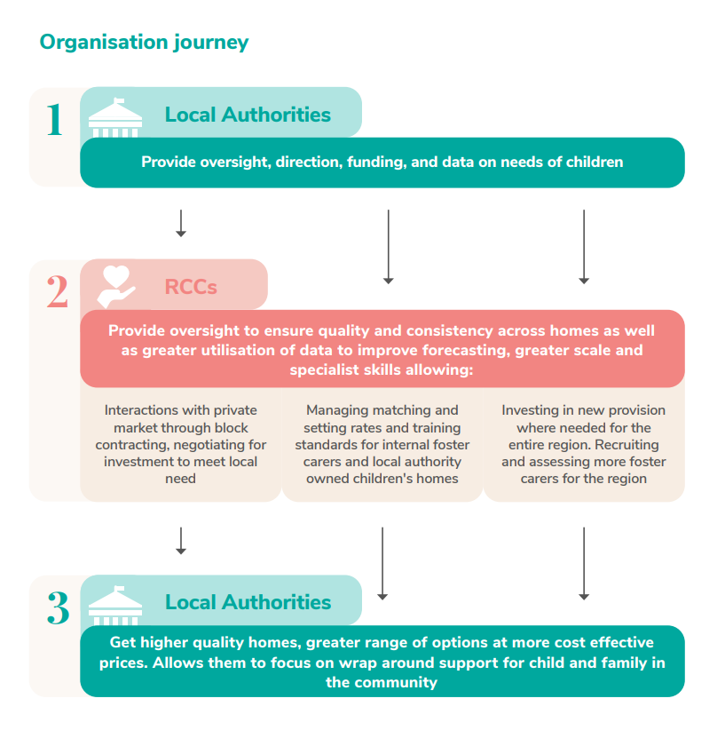
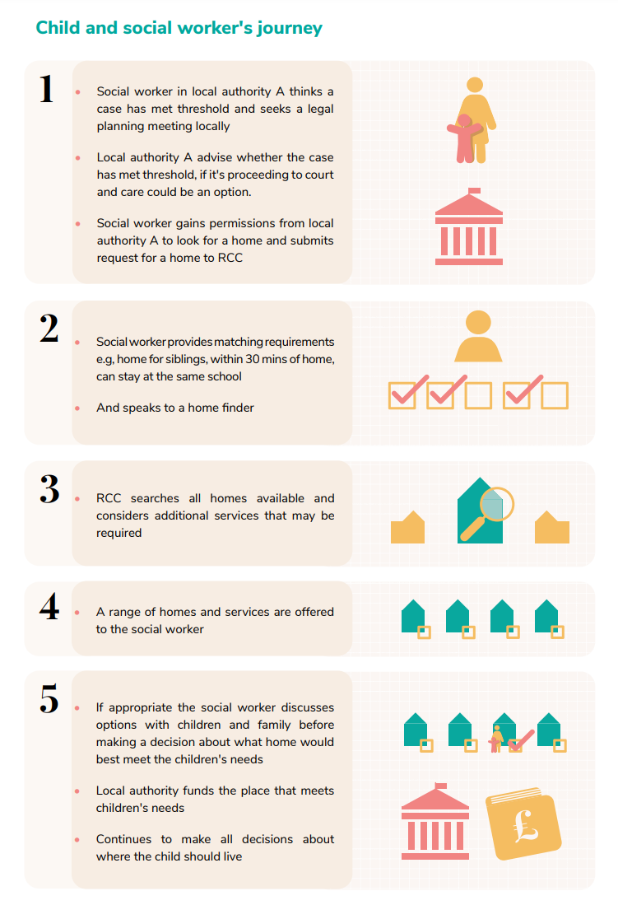

Contact
Louise Smith
Senior Adviser – Children and Young People
Mobile: 07464 652769
Email: louise.smith@local.gov.uk

